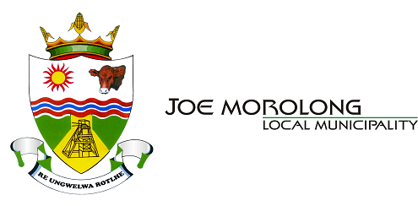

Draft IDP, Budget and Tariffs for 2017/ 18 FY Community Consultation Meeting

Notice is hereby given that Draft IDP 2017/ 22 (Five Year Plan) & Budget 2017/ 18 FY of Joe Morolong Local Municipality, compiled in terms of the Local Government Municipal Systems Act (Act 32 of 2000) and its regulations, will be presented to the community of Joe Morolong Local Municipality on the following dates and venues:

Date | Ward | Place | Time | Ward Councillors
10 April 2017 | Ward 07 | Suurdig | 09H30 | Councillor Modise
10 April 2017 | Ward 14 | Ellendale | 14H30 | Councillor Josop
11 April 2017 | Ward 03 | Penryn | 09H30 | Councillor Block
11 April 2017 | Ward 02 | Pepsi | 14H30 | Councillor Tswere
12 April 2017 | Ward 11 | Cassel | 09H30 | Councillor Matsioloko
12 April 2017 | Ward 12 | Dithakong | 14H30 | Councillor Earabang
18 April 2017 | Ward 05 | Masankong | 09H30 | Councillor Sekokodie
18 April 2017 | Ward 06 | Metsimantsi Wyk 3 | 14H30 | Councillor Seikaneng
19 April 2017 | Ward 04 | Vanzylsrus | 09H30 | Councillor Katong
20 April 2017 | Ward 09 | Danoon | 09h30 | Councillor Kaebis
20 April 2017 | Ward 13 | Dikhing | 14H30 | Councillor Mmmolaeng
21 April 2017 | Ward 15 | Ncwelengwe | 09H30 | Councillor Matebesi
24 April 2017 | Ward 08  Ward 10 | Gamorona  Madularanch | 09H30  14H30 | Councillor Mokgautsi  Councillor Sesenyi
25 April 2017 | Ward 01 | Heuningvlei | 09H30 | Councillor Mokweni

For further information and comments regarding Integrated Development Plan (IDP), please contact (IDP/ PMS Manager) Mrs M.C Melokwe at melokwe@joemorolong.gov.za and/ or Director Planning & Development) Mr K.V Phiri at vphiri@joemorolong.gov.za.

For further information regarding Budget, please contact Chief Finance Officer Mrs B.D Motlhaping at motlhapingb@joemorolong.gov.za and Ms K. Thupae (Budget and Compliance Officer) at thupaek@joemorolong.gov.za.

Mr T.M Bloom

Municipal Manager

Joe Morolong Local Municipality

Private Bag X117

Mothibistad

8474

